ASSIGNMENT-14.3

Batch-37
2303A52317

Task 1: AI-Assisted Personal Portfolio Website
Scenario
A student wants to showcase academic projects, technical skills, and contact
information through a personal portfolio website. AI tools are used to speed up
development while maintaining quality and customization.
Tasks
1. Use GitHub Copilot to generate a semantic HTML structure with
sections:
o Home
o About
o Projects
o Contact
2. Ask Copilot to suggest responsive CSS using Flexbox or Grid.
3. Customize AI-generated CSS to add:
o Hover effects on project cards
o Smooth scrolling navigation
Expected Outcome
• Clean and well-structured portfolio website
• Responsive layout for desktop and mobile screens
• Interactive project cards

Prompt:-

<!-- Create a complete personal portfolio website in a single HTML file with:
- sections: Home, About, Projects, Contact
- responsive design using CSS Grid or Flexbox
- internal CSS using <style> tag
- JavaScript for smooth scrolling and navbar highlight
- hover effects on project cards
- clean modern UI -->

Output:-



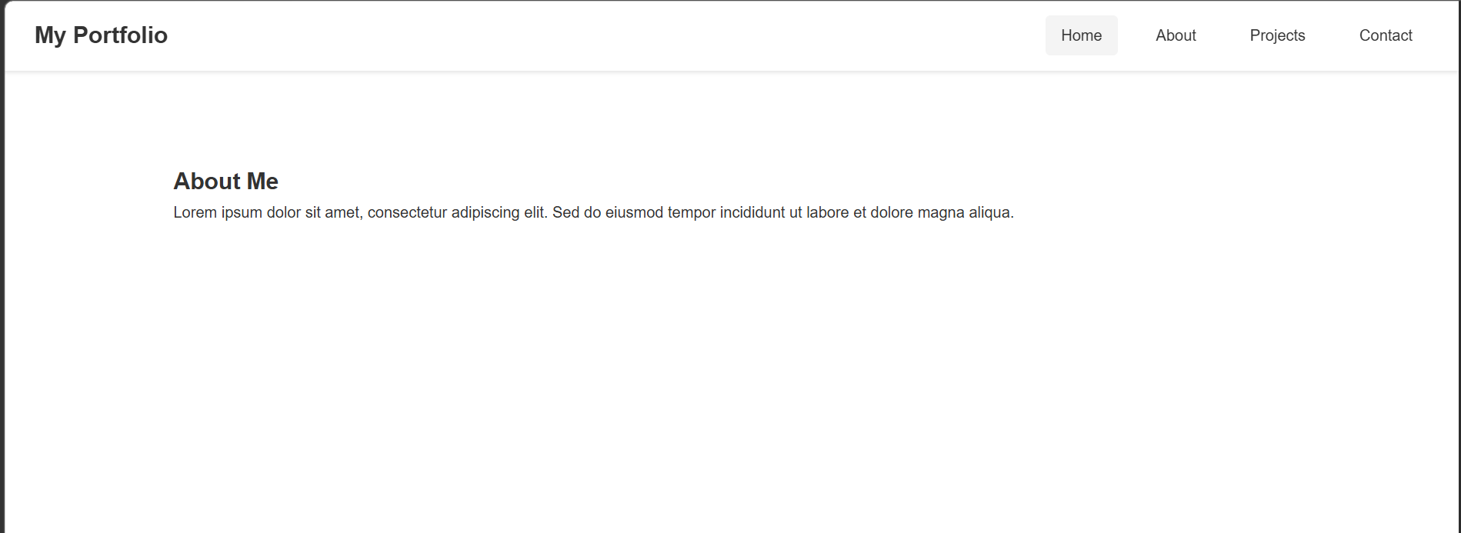

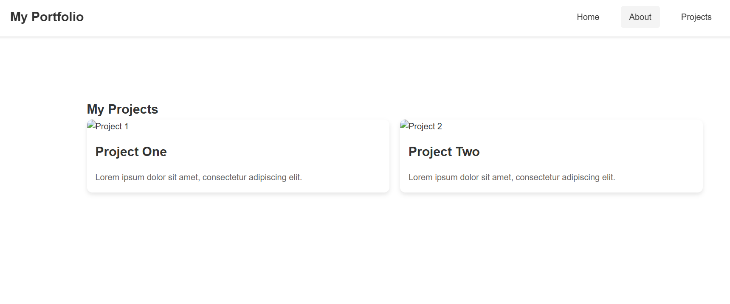
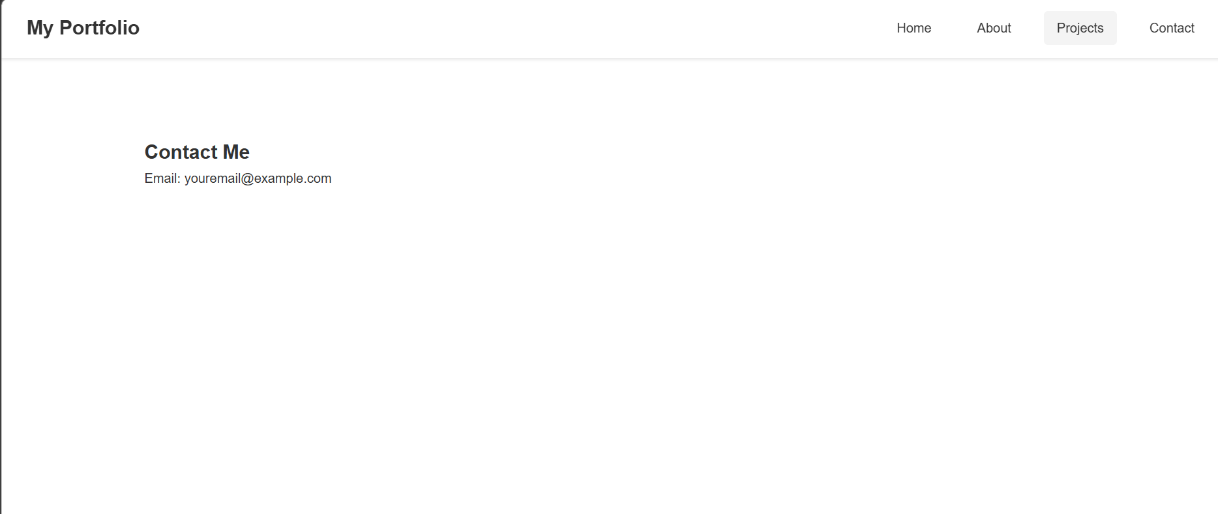

Task 2: AI-Generated Restaurant Landing Page
Scenario
A local restaurant requires a simple yet attractive landing page to display its
offerings. The developer uses AI assistance to rapidly generate UI components.
Tasks
1. Use Copilot to create a navigation bar with links:
o Home
o Menu
o Gallery
o Contact
2. Generate a menu section styled with CSS cards.
3. Implement a JavaScript-based image slider for the gallery using Copilot
suggestions.
4. Customize animations or transitions for better user experience.
Expected Outcome
• Fully functional restaurant landing page
• Responsive navigation bar
• Working image slider with smooth transitions

Prompt:-

<!-- Create a modern restaurant landing page in a single HTML file with:
- navigation bar with Home, Menu, Gallery, Contact
- responsive design using Flexbox or Grid
- menu section with stylish food cards
- image gallery with JavaScript slider
- smooth animations and transitions
- internal CSS and JavaScript
- attractive colors and clean UI -->

Website ➖

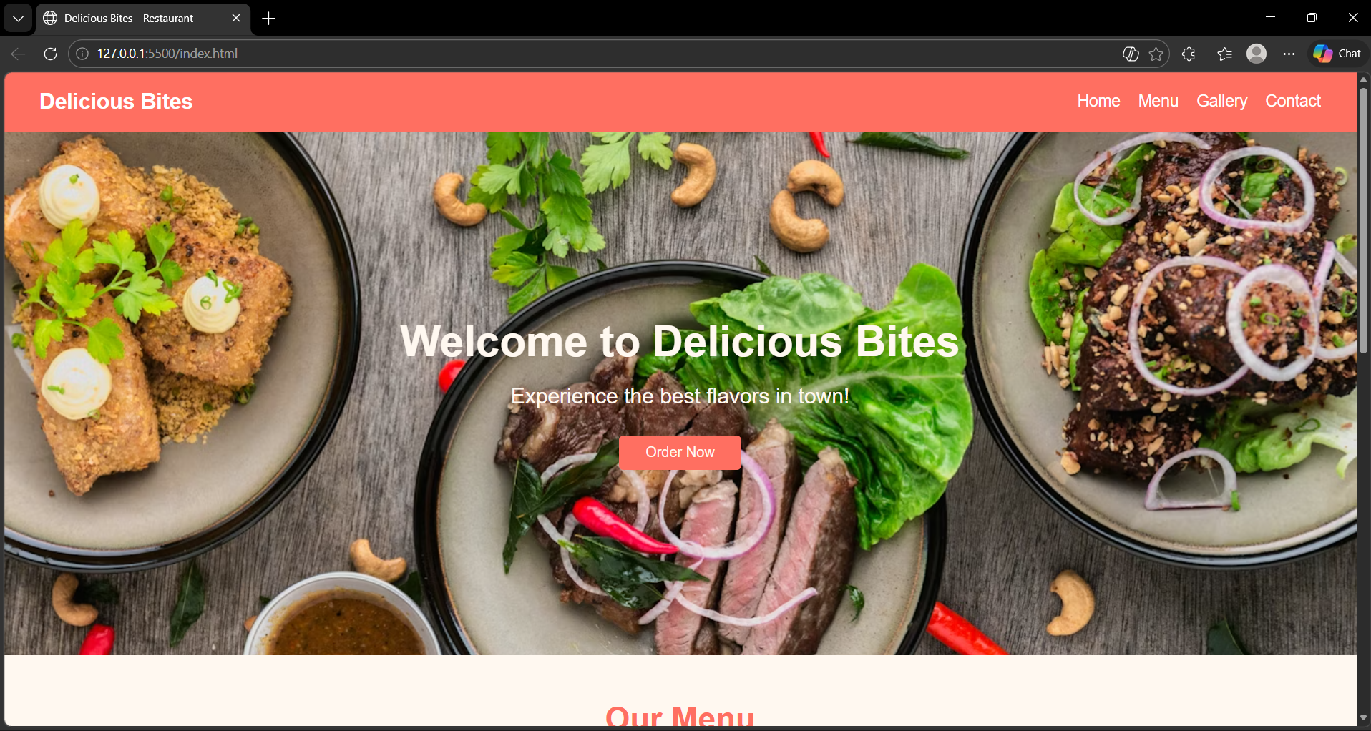

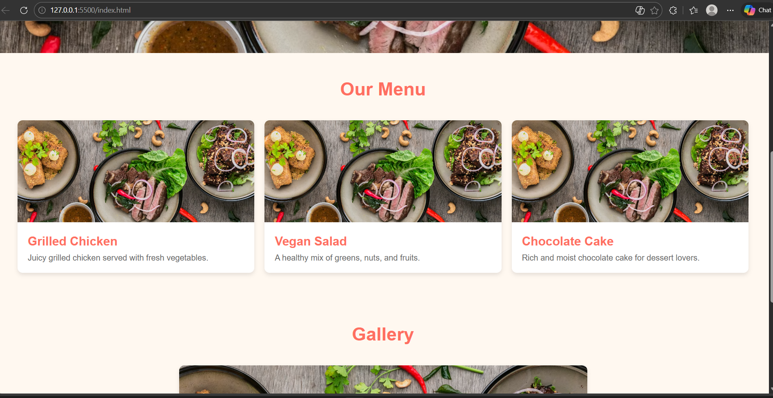

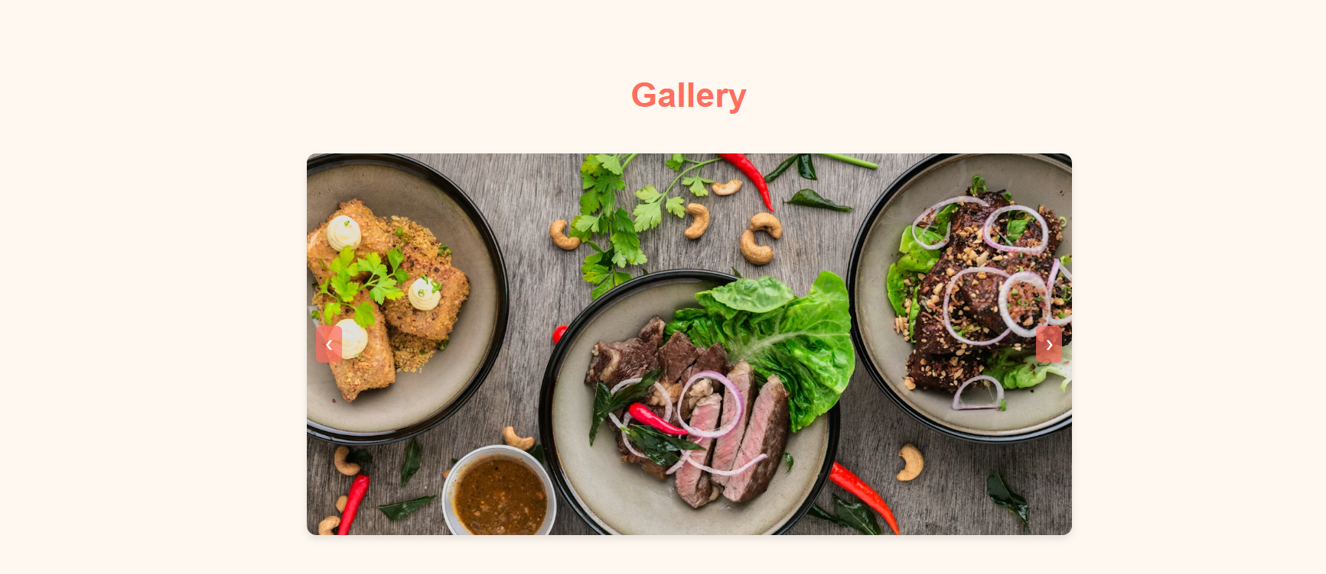

Task 3: AI-Powered Event Registration Form
Scenario
SR University is hosting a technical fest and requires an online registration form
with real-time validation to ensure accurate user input.
Tasks
1. Ask Copilot to generate an HTML form with the following fields:
o Name
o Email
o Phone Number
o Department
o Event Selection
2. Use AI assistance to style the form using CSS for readability and
accessibility.
3. Implement JavaScript validation using Copilot:
o Email format validation
o Phone number length validation
o Required field checks
Expected Outcome
• User-friendly and visually appealing form
• Real-time validation messages
• Prevention of invalid submissions

Prompt:-

<!-- Create a technical fest registration form for SR University in a single HTML file with:
- fields: Name, Email, Phone Number, Department (dropdown), Event Selection (dropdown)
- clean and modern UI design
- responsive layout
- CSS styling for readability and accessibility
- JavaScript validation with real-time error messages
- validate email format, phone number length (10 digits), and required fields
- prevent form submission if inputs are invalid -->

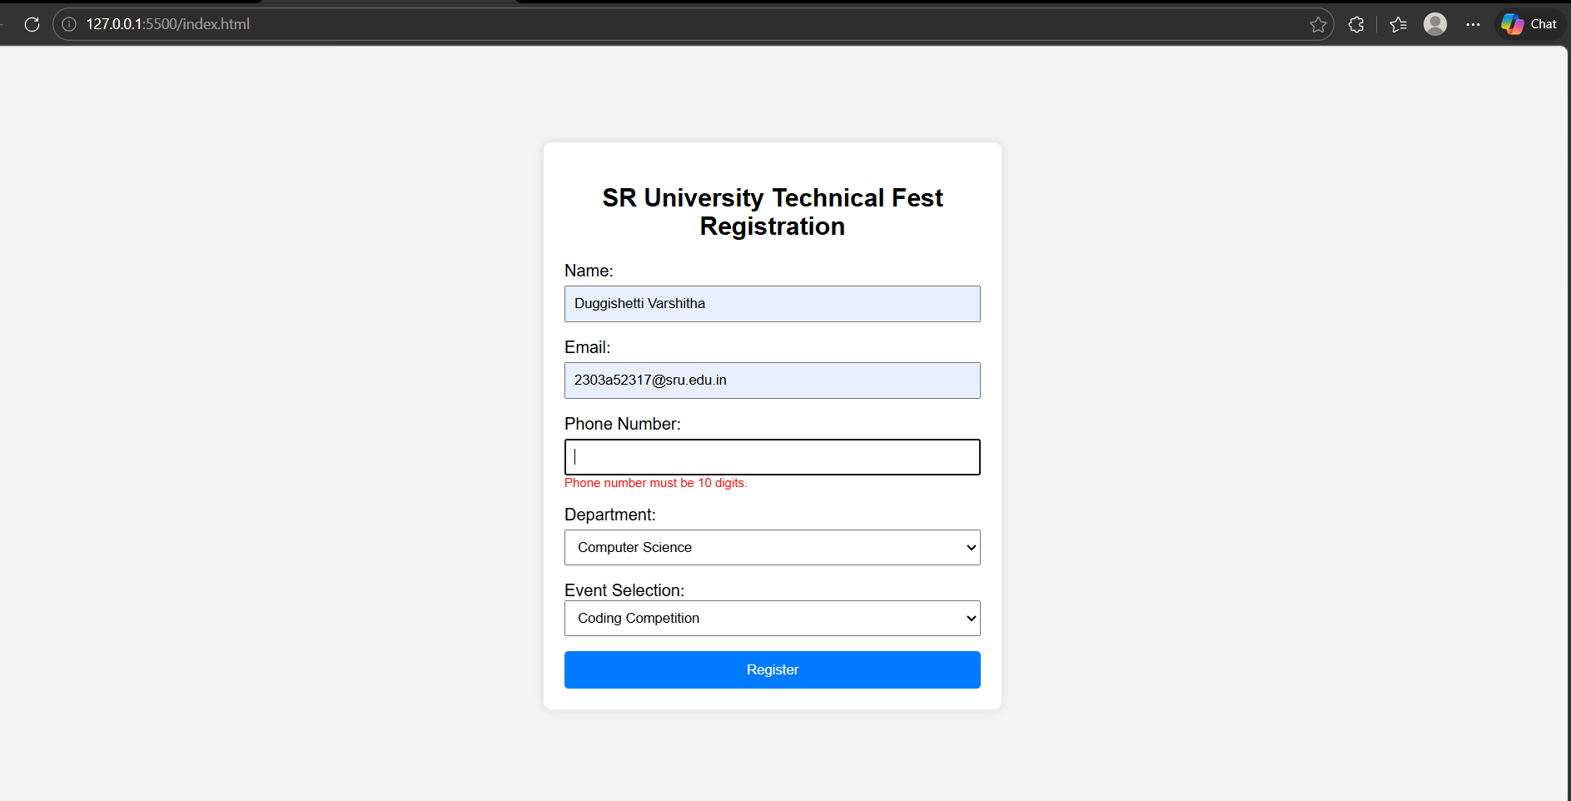

Task 4: AI-Assisted E-Commerce Product Page
Scenario
A startup is developing a basic e-commerce product page to showcase products
and manage simple cart functionality.
Tasks
1. Use Copilot to generate a grid-based product catalog using HTML and
CSS.
2. Implement an “Add to Cart” feature using JavaScript.
3. Modify AI-generated code to include:
o Cart item counter at the top-right corner
o Visual feedback when a product is added
Expected Outcome
• Functional product catalog
• Working cart counter
• Interactive user experience

Prompt:-
<!-- Create a simple e-commerce product page in a single HTML file with:
- a responsive grid-based product catalog using CSS Grid
- each product card should include image, title, price, and "Add to Cart" button
- a cart icon at the top-right corner with item count badge
- JavaScript functionality to add items to cart and update counter
- visual feedback when a product is added (like button color change or message)
- clean modern UI design with hover effects
- responsive layout for mobile and desktop
- internal CSS and JavaScript -->

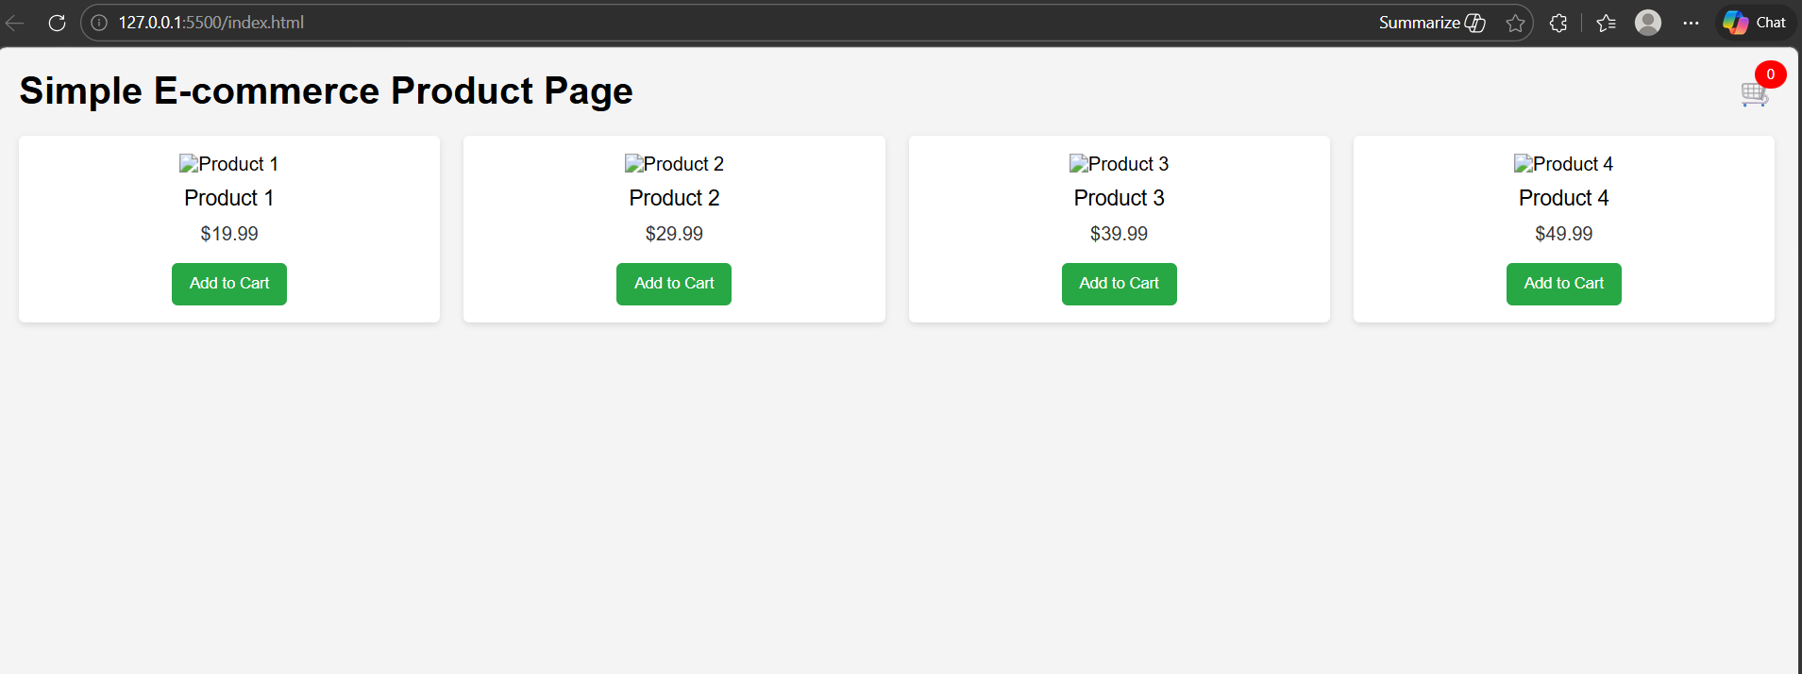

Task 5: Create a Responsive Web Page Layout
Instructions:
• Design a basic web page layout with a header, main content area, and
footer using HTML and CSS
Use AI to assist in generating responsive CSS for different screen sizes.
• Ensure the layout is clean and visually organized.
Expected Output:
• A responsive web page with:
• Header with navigation links
• Main section with placeholder text/images
• Footer with copyright or contact info
• Layout adapts correctly to desktop, tablet, and mobile screen sizes.

Prompt:-

Generate a responsive web page using HTML and CSS.
Include a header with navigation links, a main section with placeholder text and images, and a footer with copyright or contact information.
Use responsive CSS with Flexbox or Grid and media queries so the layout adapts properly for desktop, tablet, and mobile screen sizes while keeping the design clean and visually organized.

